1. Open Outlook
2. Click on the Calendar icon from the left side of the window

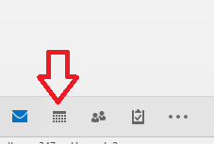

1. On the right side a new window will appear

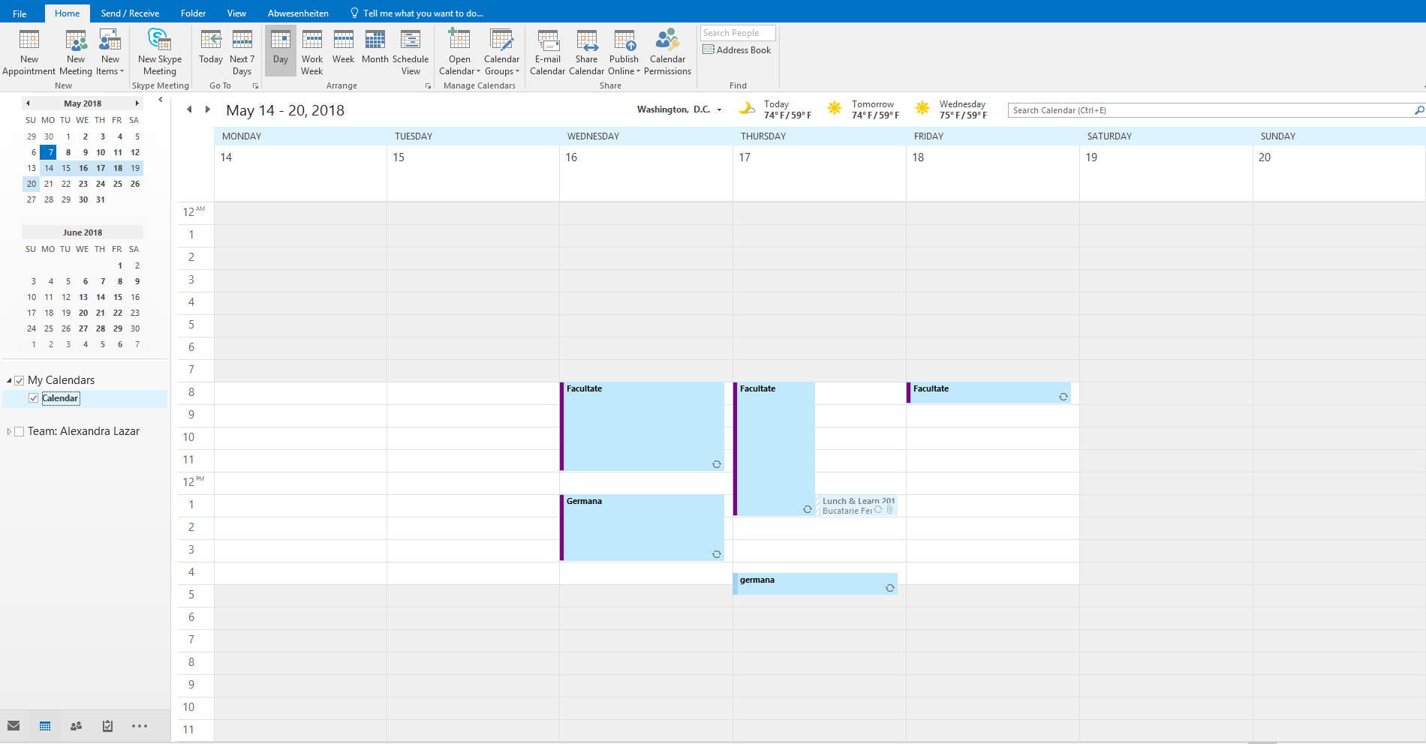

1. Select a period of time by click and drag from start time to end

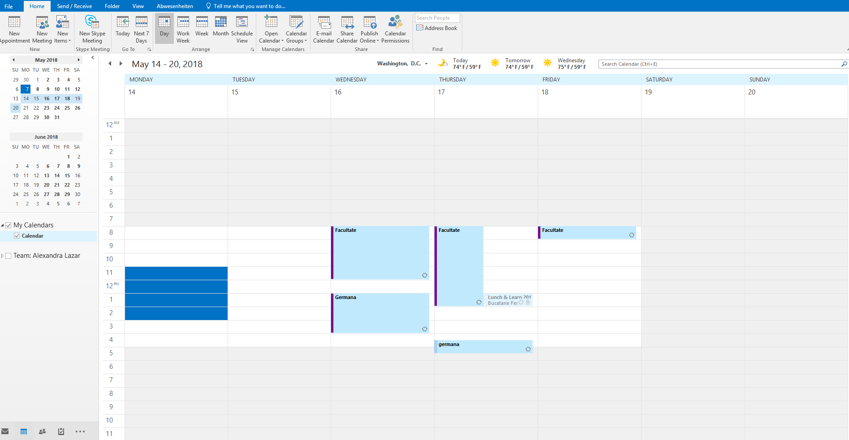

1. Right click on the selected period of time

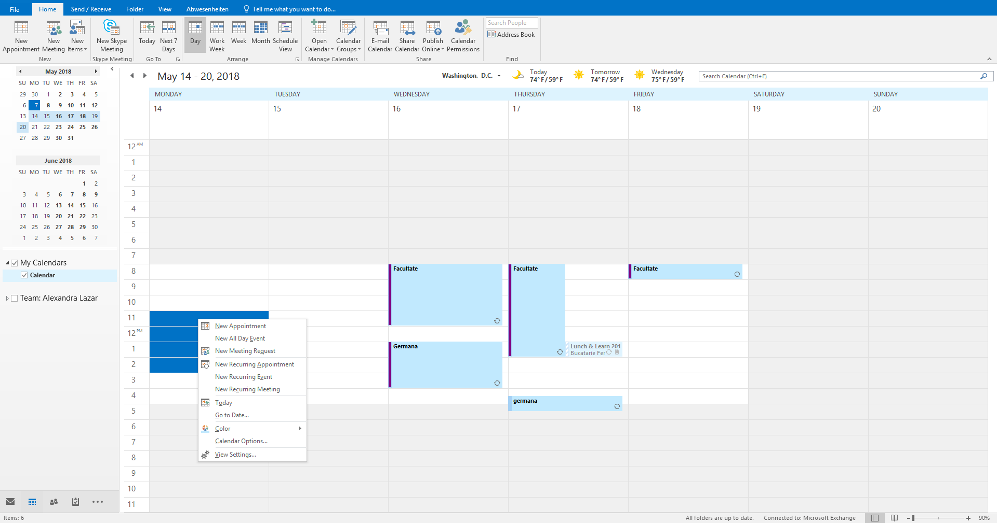

1. Event type selection
   1. If it is a weekly appointment select “New Recurring Appointment”

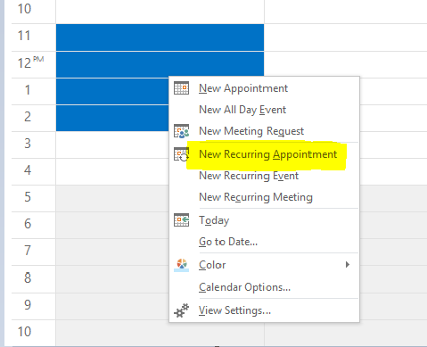

* 1. If it is only for a day select “New Appointment”

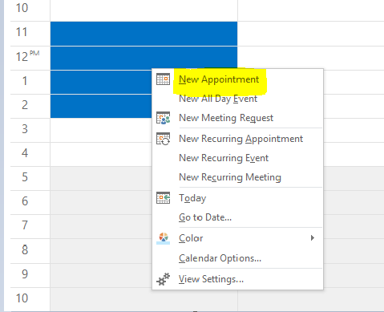

1. After the event type is selected a new window will be opened
   1. Recurring appointment – in the pop up, the event can be set as weekly, monthly or yearly and you can select the days of the week in which the event is displayed

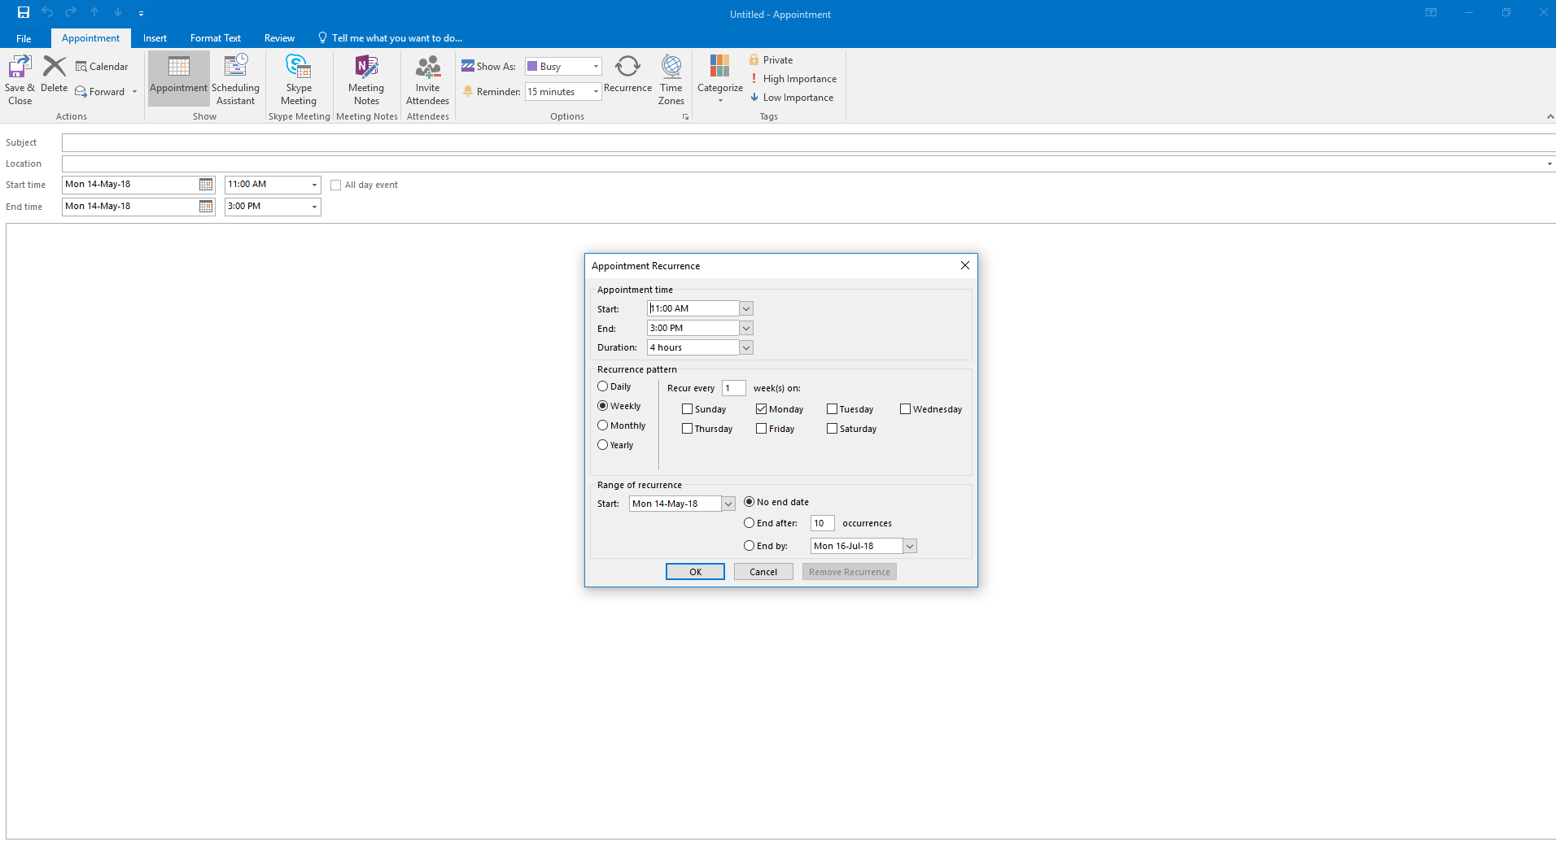

* 1. Single Appointment selection will open the same window but without the pop up “Appointment Recurrence”

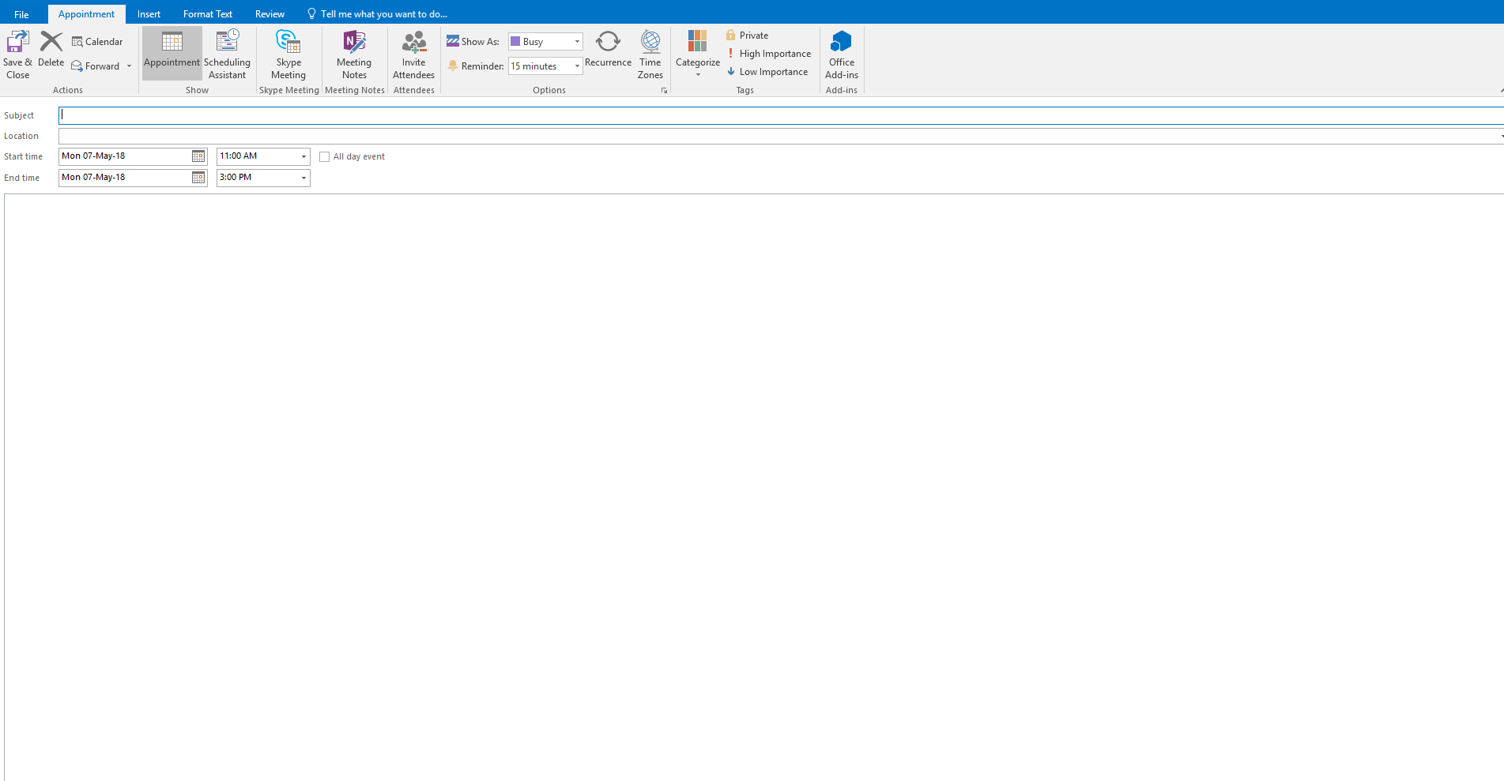

In both cases, the time and date can be changed.

1. Write a title for the appointment as shown below and select a “Shown as” option from the drop down list

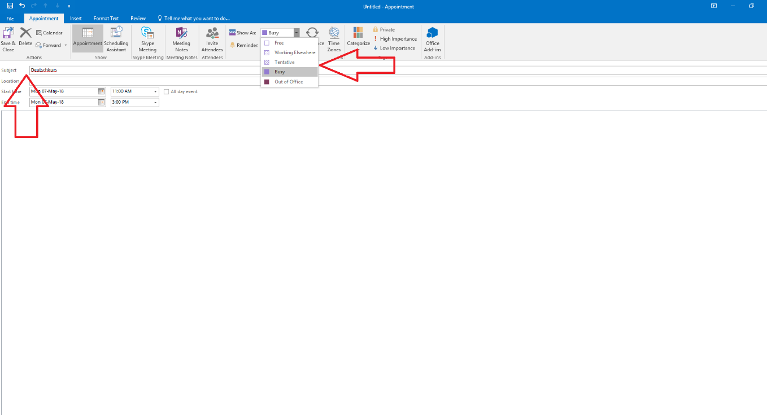

1. Click on “Save and Close”